1.Steps For Installion Of Git

Step 1

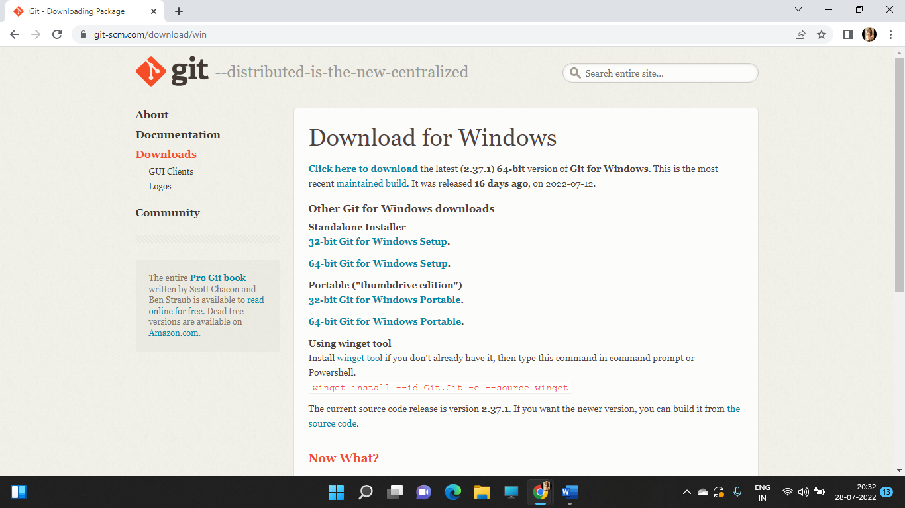

Step 2

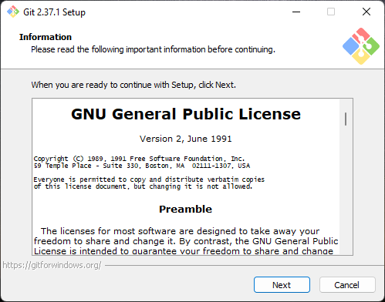

Step 3

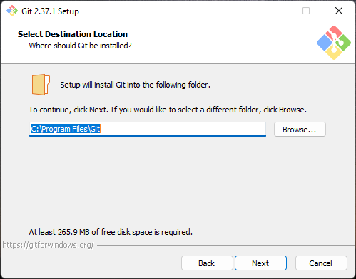

Step 4

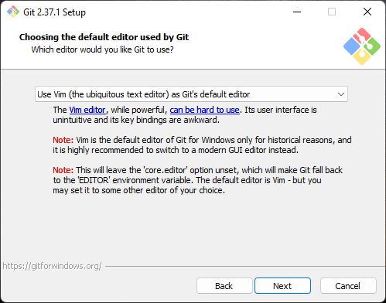

Step 5

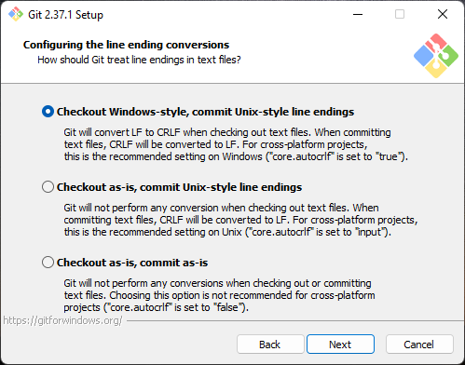

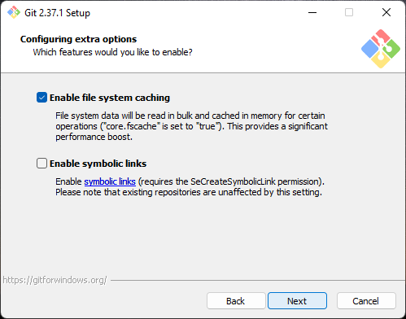Step 6

Step 7

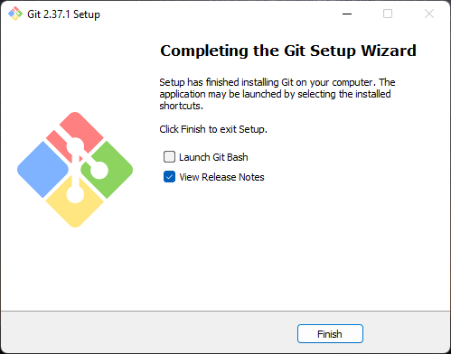

Git Commands

1.Git Login

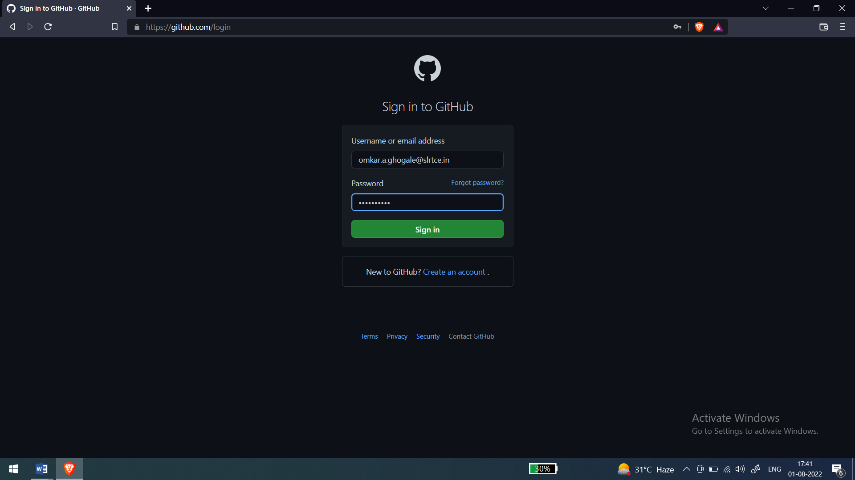

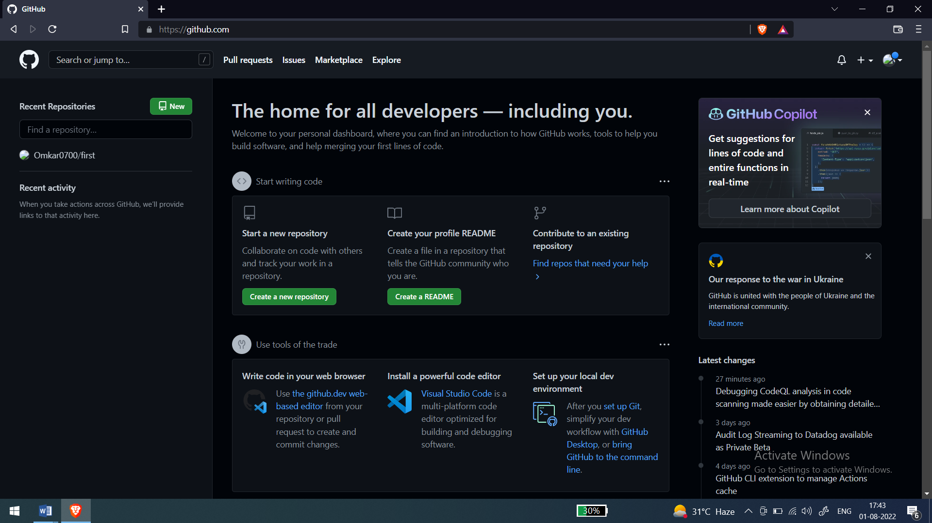

2.Ls

Ls command is used to list components in your current directory

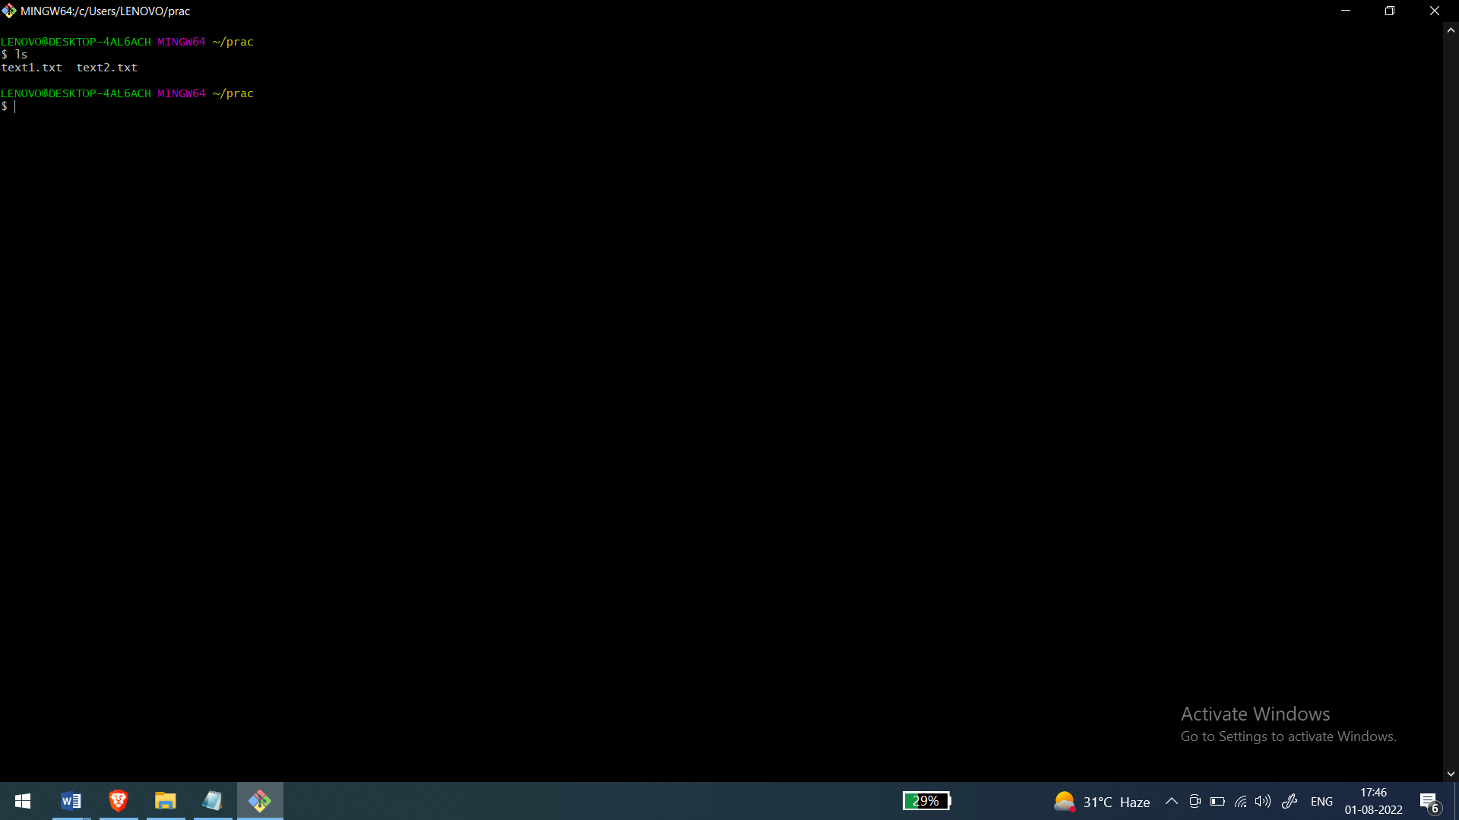

3.Mkdir

Used to make a new directory

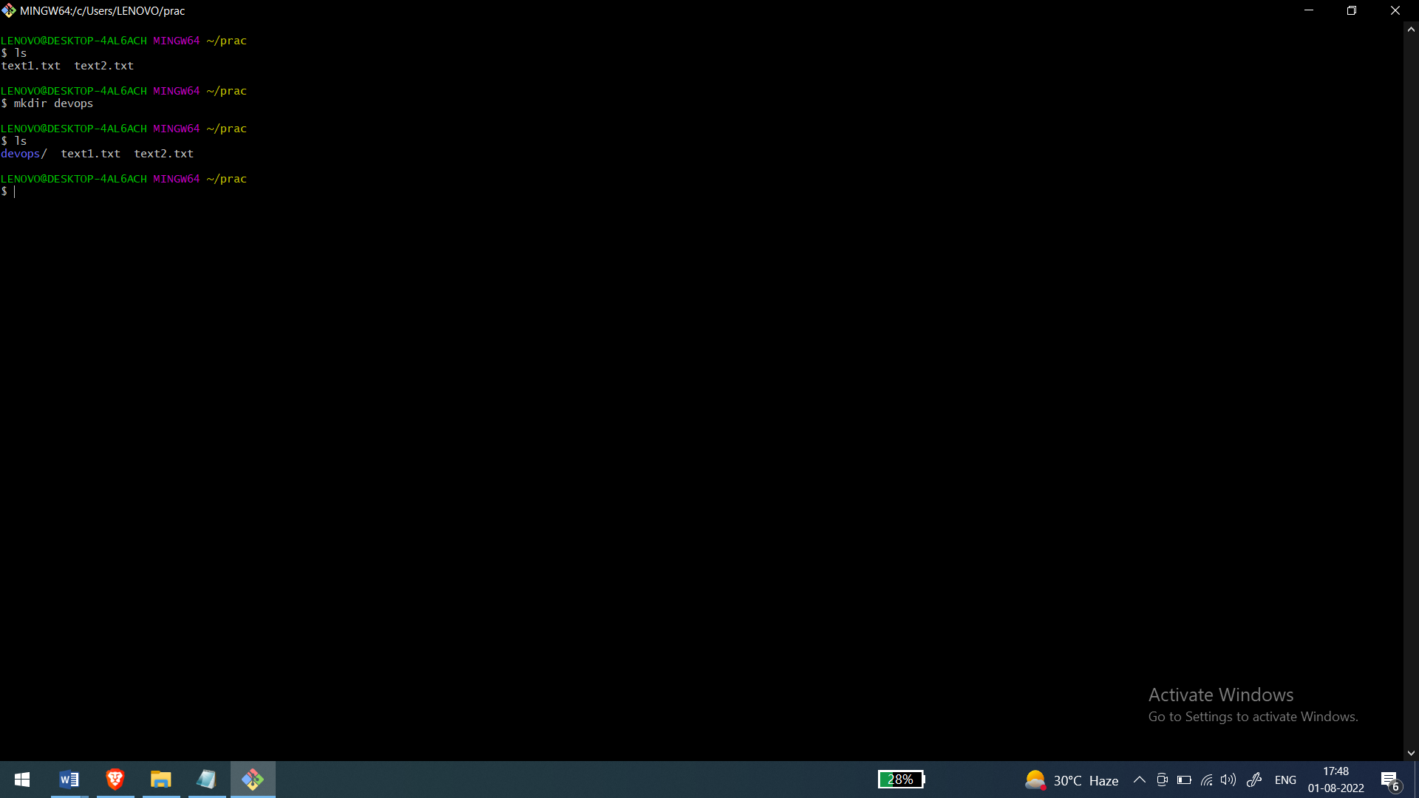

4.Git init

It is to initilize git inside the directory

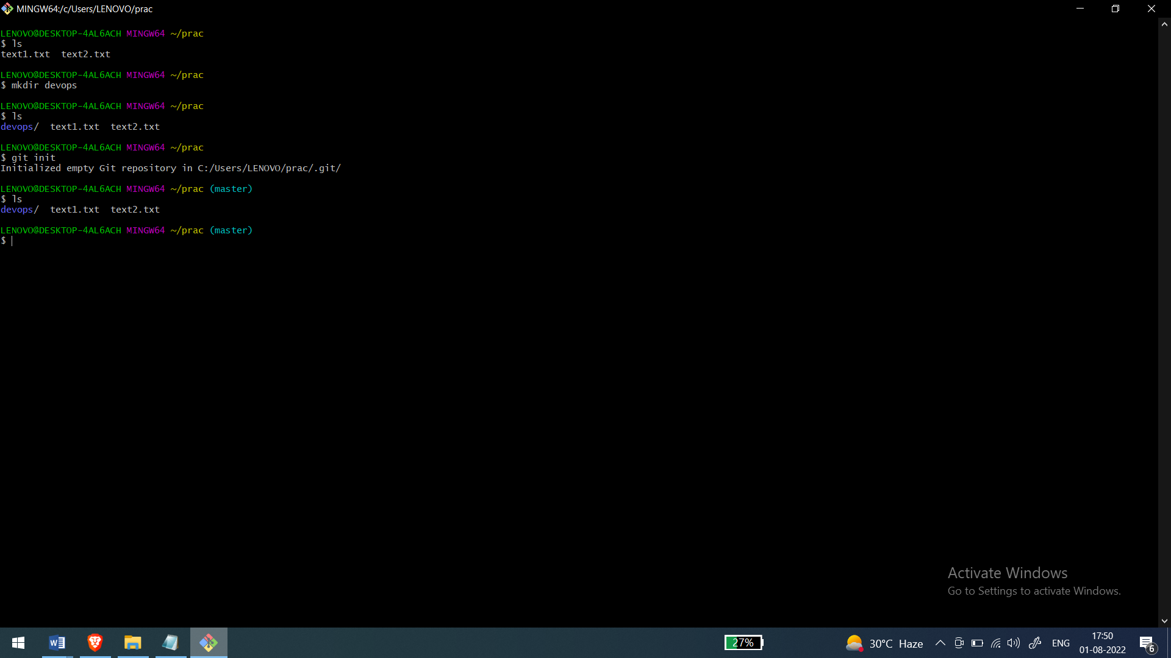

5.Git Status

It gives the status about the file in your current directory .That helps to know if your file is in which stage

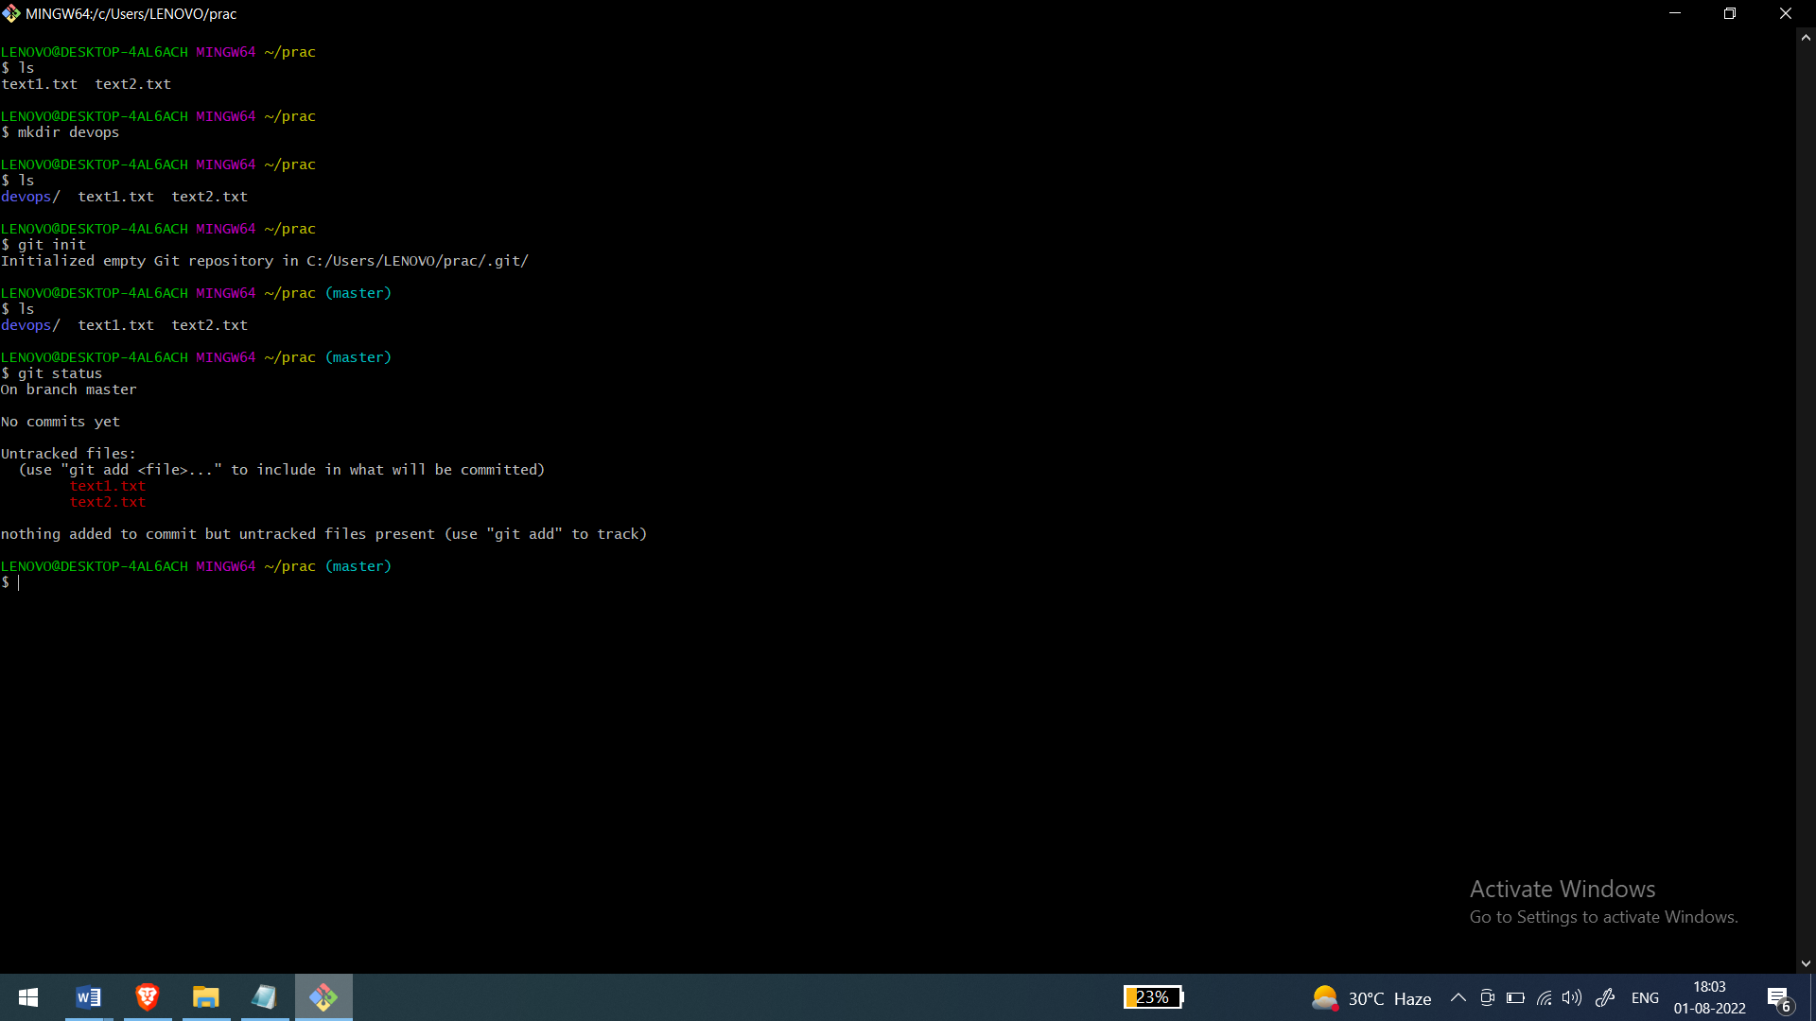

6.Git Add

It is use to add components to the staging area

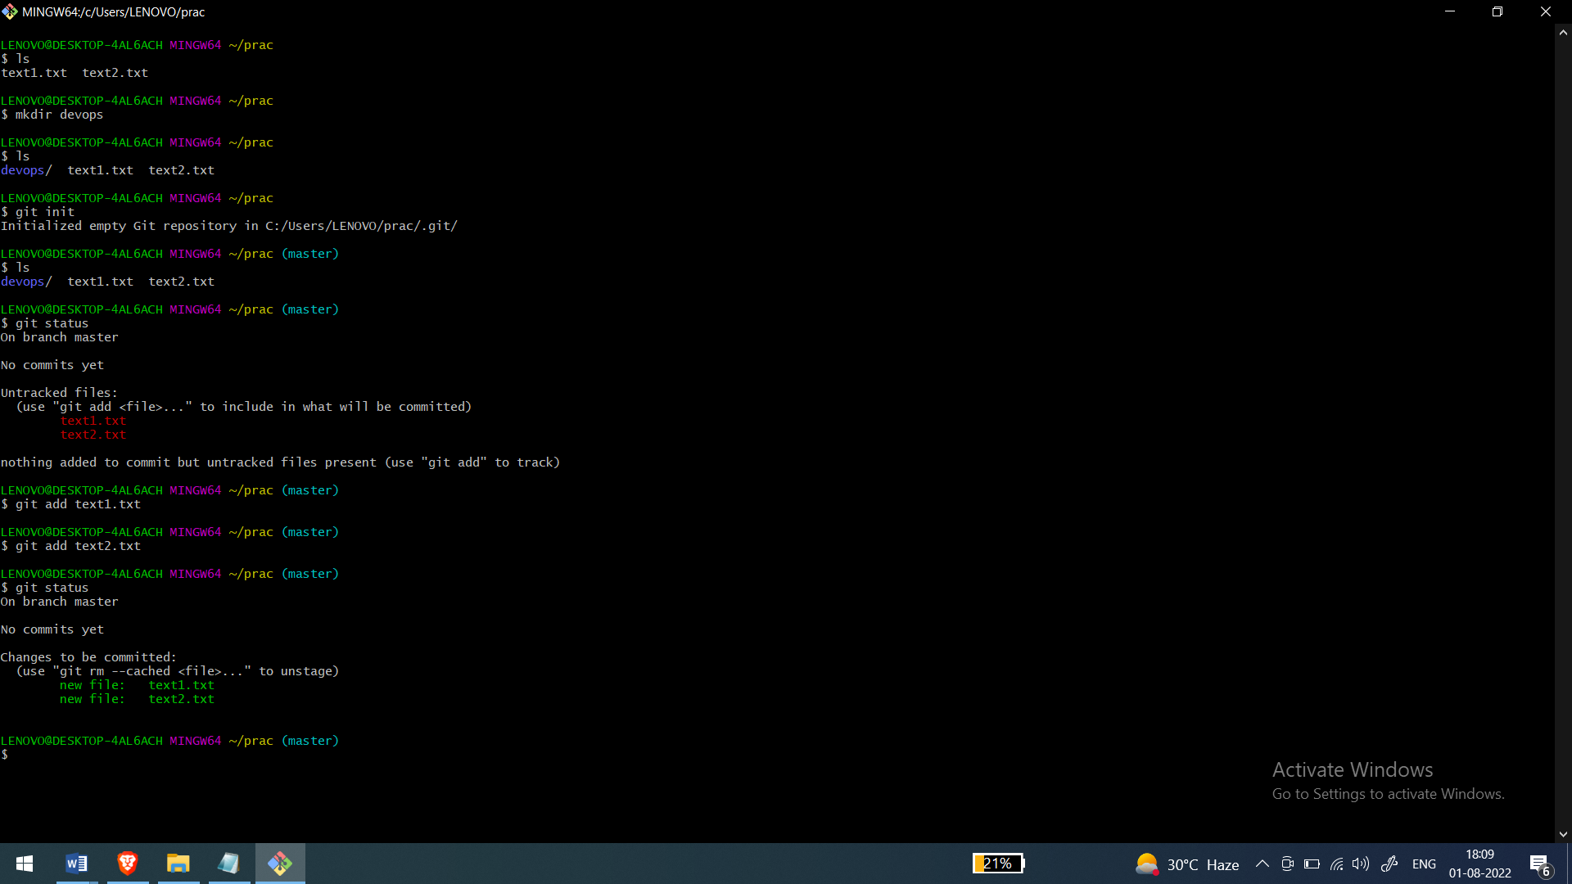

7.Git Config

It is used to do configuration of user details that changing name ,email of local and global users.

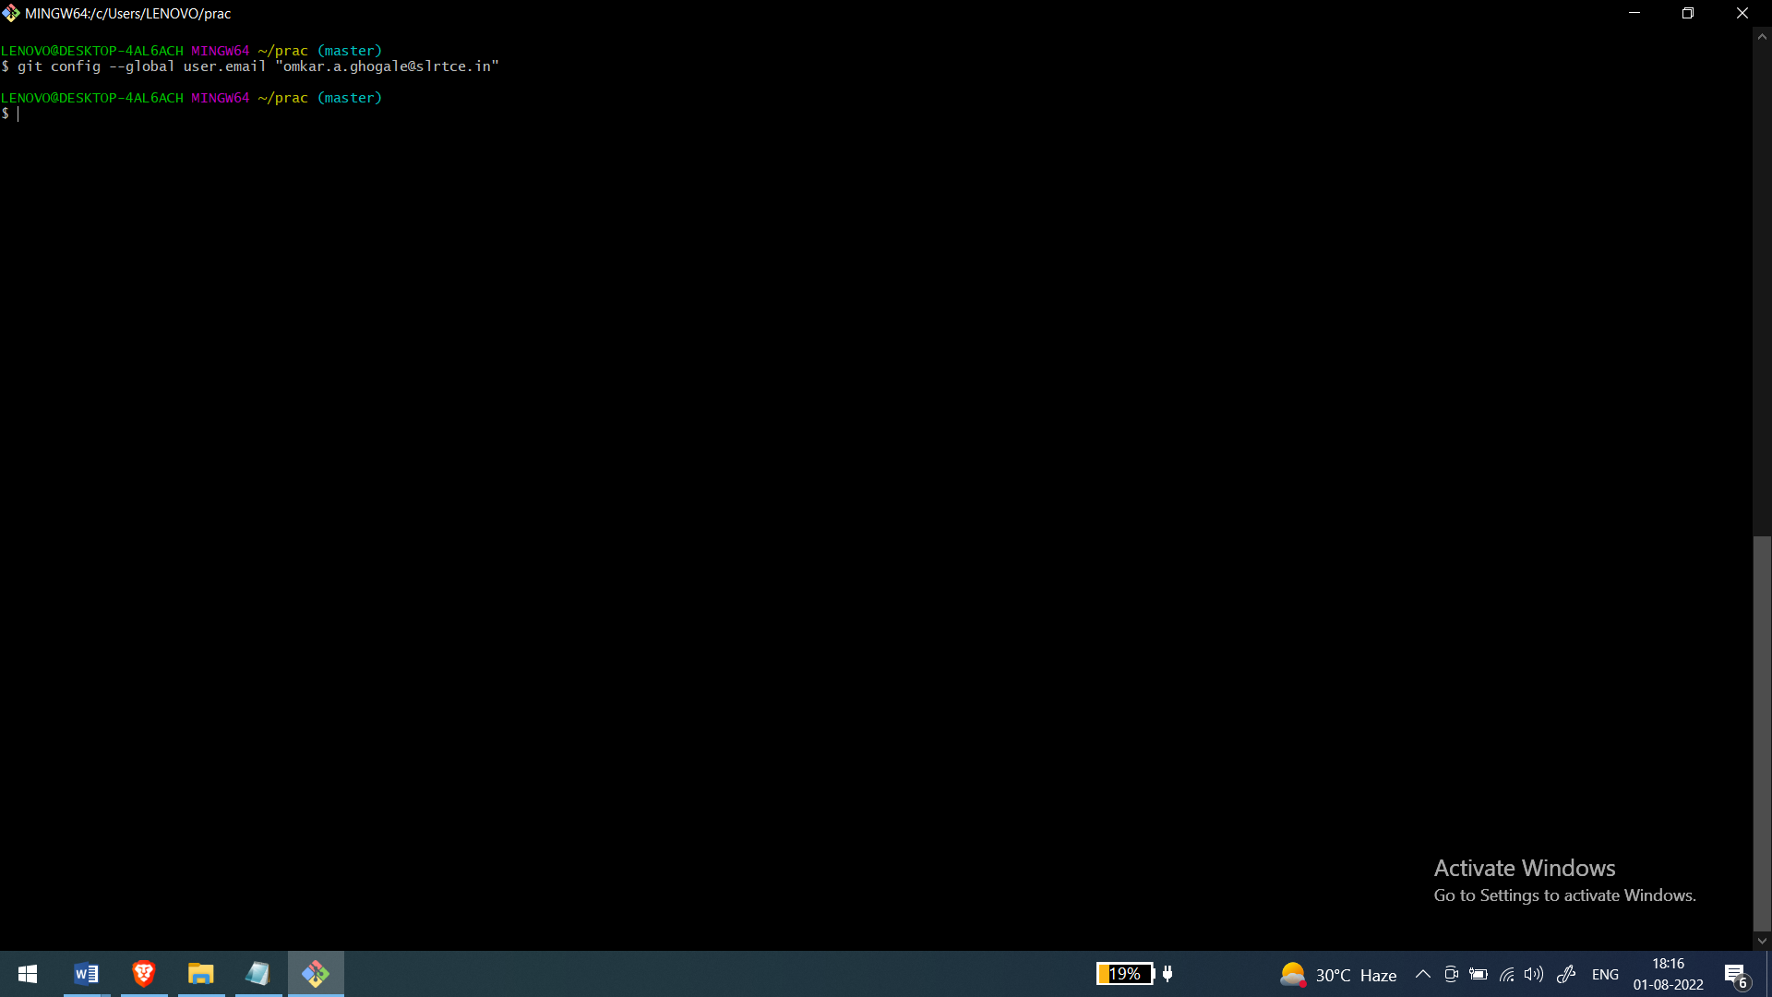

8.Git Commit

It used to commit changes to the repository Basically used to create a snapshot of your environment

